Time Series Analysis of Personal Consumption Expendidures

*Abstract*— In this project, prediction of Personal Consumption Expenditures is shows by using different forecasting models. ARIMA, ETS, TBATS, PROPHET, and NN are used for models. All tests are conducted by using R-Studio. Before starting the analysis, the data set was cleaned from dirty data and made stationary. Then, the performances of the models were compared according to various criteria using the test and train sets.

Keywords—Forecast, Personal Consumption Expenditures, nnetar, ets

# INTRODUCTION

The main purpose of this study is to understand the behavior of personal consumption expenditures. The data collected by the United States Bureau of Economic Analysis (BEA). To get rid of the pandemic effect, Personal consumption expenditures (PCEs) dataset taken between 1959.01.01 and 2018.12.01. It is analyzed and explored. The data set is consist of seasonally adjusted annual rates, unit is billions of dollars and frequency of the data set is month.

Moreover, the Personal consumption expenditures values are forecasted using ARIMA, ETS, TBATS, Neural Network and Prophet models. After that, model performances were compared by looking root mean squared error (RMSE), mean absolute error (MAE), mean absolute percentage error (MAPE).

# DATA DESCRITPION AND PREPROCESSING

The data set is taken from Economic Research website:

https://fred.stlouisfed.org/series/PCE.At the beginning of the analysis, the data set is divided into test set and train set. While doing this, the last 144 observations are kept as test set since the data set has 720 data points which is between 1959.01.01 and 2018.12.01(%80 of the data set used for train). Then, we check the anomalies in the data by using stl decomposition and shown that the series has anomalies.

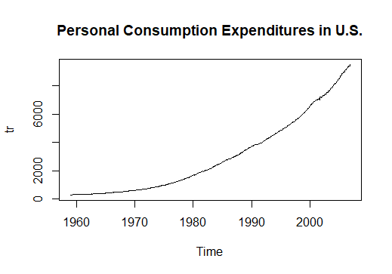

***Graph 1****: Time Series Plot of Data Set*

It can be seen that the plot seems non-stationary, and mean term is not constant. Also, it seems there is an increasing trend. However, we haven’t known the type of trend yet.

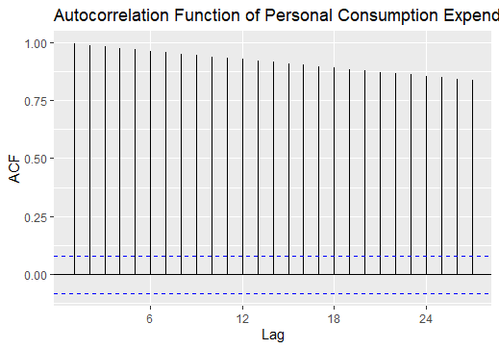

***Graph 2****: ACF Plot of Data Set*

It can be seen from the ACF plot that there exists linear slow decay, so, it clearly shows that the process is not stationary.

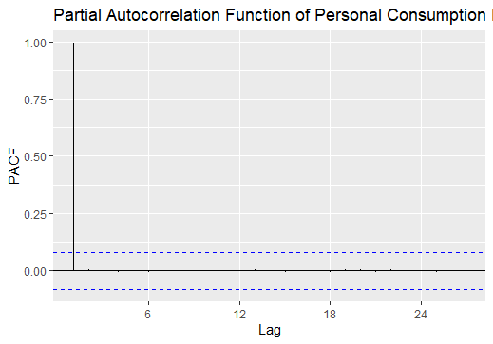

***Graph 3****: PACF Plot of Data Set*

The process is not stationary; hence it is not necessary to interpret the PACF plot.

In time series models, when we face with non-stationary process, applying variance stabilizing transformation will make the data get suitable to meet with necessary assumption. Therefore, after cleaning dirty data, then box-cox transformation was applied.

According to result of Hegy test, p value of tpi_1 for regular unit root , p-value=0.1 > 0.05,we have regular unit root. Also, Fpi_11:12 for testing seasonal unit root, p-value=0.01 <0.05 ,so we do not have any seasonal unit root. In order to solve this problem, regular differencing was taken two times. In addition, stationarity was tried to be obtained by taking a regular difference and then a seasonal difference. However, since over differencing was encountered, it was continued as regular differencing was taken 2 times.

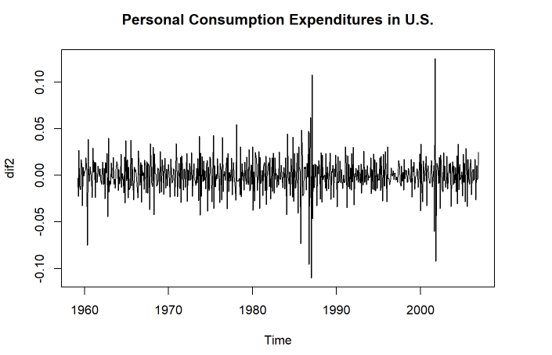

***Graph 4****: Time Series Plot of Differenced Data Set*

# MODEL SUGGESTION

After obtaining stationary data, graphs were drawn again to suggest models.

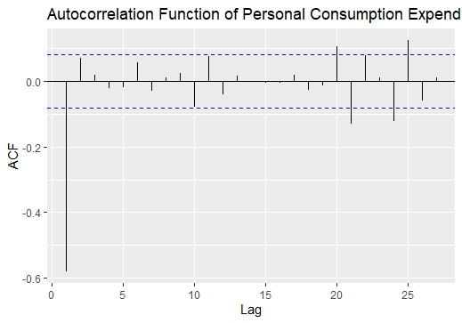

***Graph 5****: ACF Plot of Stationary Data Set*

By looking this plot, we identify the MA order of process.

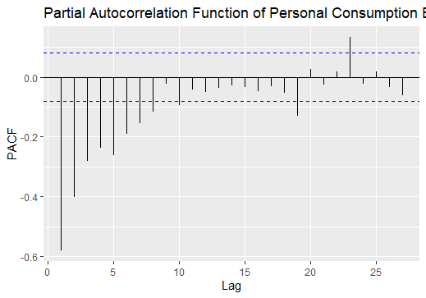

***Graph 6****: PACF Plot of Stationary Data Set*

It can be seen that PACF shows the exponential behavior which is a identify AR process. Therefore by looking both ACF and PACF plot, the suggested models are ARIMA (3,2,1)(2,0,2)12 and ARIMA (3,2,1)(0,0,2)12 for this data set.

Besides, The Extended Sample Autocorrelation Function (ESACF) method can identify the ARMA process.

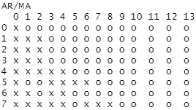

In ESACF method, we select the model with less parameters by drawing a triangle consisting of “o” terms. Therefore, we can suggest ARIMA (0,2,1), ARIMA (0,2,3)

ARIMA (2,2,3) and ARIMA (0,2,3) models.

# MODELLING AND DIAGNOSTIC CHECKING

After the proposed models were fitted, it was found that which model gave the best performance and whether it was significant or not.

Thus, it is seen that ARIMA (2,2,1) and ARIMA (0,2,1) are found as significant models. Now, the AIC values are used to find the most suitable model. Since ARIMA (0,2,1) has the smallest AIC value, it is selected as the most appropriate model. After choosing best model, we will continue with diagnostic checks.

|  |
| --- |
| **ARIMA (2,2,1)** |
| **Coefficients: ar1 ar2 ma1**  **-0.2899 -0.1082 -0.9587**  **s.e. 0.0428 0.0427 0.0114** |
| **sigma^2 estimated as 0.0001625:**  **log likelihood=1689.78**  **AIC=-3371.56 AICc=-3371.49 BIC=-3354.15** |

***Table 1:*** *Summary of Model (fit1)*

***Table 2:*** *Summary of Model (fit4)*

|  |
| --- |
| **ARIMA (0, 2, 1)** |
| **Coefficients:**  **ma1**  **-0.9748**  **s.e. 0.0075** |
| **sigma^2 estimated as 0.0001745:**  **log likelihood = 1667.65, aic = -3331.31** |

After deciding the best model, we will move on to the model's diagnostic checks. Firstly, normality assumption was checked.

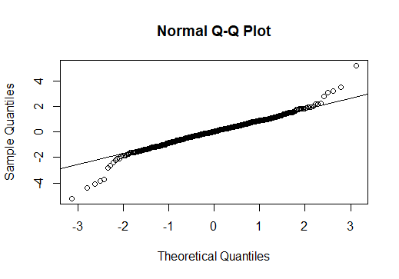

***Graph 7****: QQ plot of the standard residuals*

Since the Q-Q plot shows the symmetrical shape, we can say that residuals follow normality. To be sure about normality, Shapiro-Wilk test was applied. The result is that error is not follow normal distribution, since p-value is less than alpha. To solve this problem, transformation can be applied.

Secondly, the serial autocorrelation was checked Breusch Godfrey test and Ljung-Box test were used. Also, we can check ACF plot of residuals. So as to say that we do not have correlation problem, all spikes should be in the White Noise band.

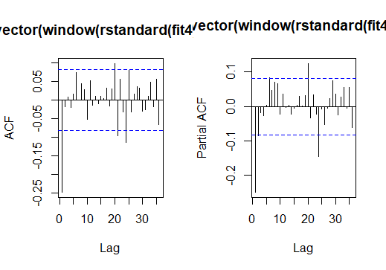

***Graph 8****: ACF Plot of the standard residuals*

It can be seen from the Graph 8 that all spikes are not in the White Noise. Thus, the assumption did not satisfy.

To be sure, the formal tests are applied should apply formal tests. Box-Ljung and Box-Pierce are applied, and they show that there is serial correlation between the residuals.

Lastly, the heteroscedasticity assumption was checked. To test this assumption, we can look at the ACF and PACF plot of squared residuals.

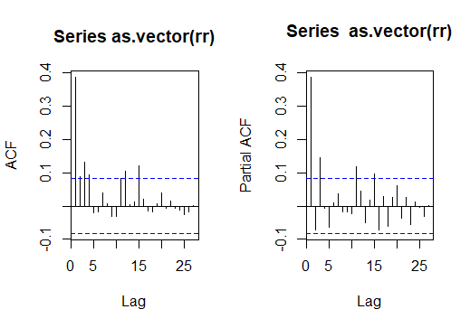

***Graph 9****: ACF and PACF of the squared residuals*

According to Graph 9, all squared residuals are not in the 95% White Noise Band. Hence, the result is that the errors are not homoscedastic. Moreover, we can apply Studentized Breusch-Pagan test to be sure. Thus, we do not have constant variance over time, and we need to use of GARCH or ARCH type model. The ARCH model will give in the appendix part.

After ARIMA model, best exponential smoothing model is tried to find, using ets function under forecast package in R. The best exponential smoothing model for the series is given below.

***Table 3:*** *Summary of ETS Model*

|  |
| --- |
| **ETS(M,A,N)** |
| **Call:**  **ets(y = tr, model = "MAN")**  **Smoothing parameters:**  **alpha = 0.7172**  **beta = 0.055** |
| **Initial states:**  **l = 305.2523**  **b = 1.5488** |
| **sigma: 0.0055**  **AIC AICc BIC**  **6345.532 6345.637 6367.313** |

After exponential smoothing model, TBATS model is fitted to the series. The model details are given below.

***Table 4:*** *Summary of TBATS Model*

|  |
| --- |
| **TBATS(0.131, {0,0}, 1, -)** |
| **Parameters** |
| **Lambda: 0.130525**  **Alpha: 0.6945047**  **Beta: 0.02945525**  **Damping Parameter: 1** |
| **Seed States:**  **[,1]**  **[1,] 8.522030833**  **[2,] 0.009327878**  **attr(,"lambda")**  **[1] 0.1305253** |
| **Sigma: 0.01424722** |
| **AIC: 6317.49** |

After fitting the model, the residuals of the TBATS model is checked by Shapiro-Wilk test and seen that they do not follow normal distribution. (p<0.05)

Then, fit Neural Network model is showed.

***Table 5:*** *Summary of NNETAR Model*

|  |
| --- |
| **Model: NNAR(1,1,2)[12]** |
| **Call: nnetar(y = tr)** |
| **Average of 20 networks, each of which is**  **a 2-2-1 network with 9 weights**  **options were - linear output units** |
| **sigma^2 estimated as 375.1** |

Lastly, prophet model was fitted. When we check the residuals of the models, we see that they are not normally distributed with respect to Shapiro-Wilk test. (p<0.05).

After fitting the models, we obtain forecast values from each method using forecast function and calculate their accuracy. The accuracy of the models are shown below table.

***Table 6:*** *The train accuracy of models*

|  |  |  |  |
| --- | --- | --- | --- |
|  | **RMSE** | **MAE** | **MAPE** |
| ETS | 1028.32396 | 938.77738 | 8.0236609 |
| TBATS | 2122.052 | 1833.17987 | 15.2313694 |
| PROPHET | 4119.777 | 4112.421 | 36.53739 |
| NNETAR | 1737.86608 | 1288.51401 | 10.2971641 |
| ARIMA | 2207.21 | 1905.187 | 15.82383 |

According to table shows that ETS model outperforms the other methods in comparison of both train and test set with respect to all measures. Also, we can say that NNTAR has the second-best forecasting performance when compared to other models.

The forecasting performance of the best models can be also observed from following plots

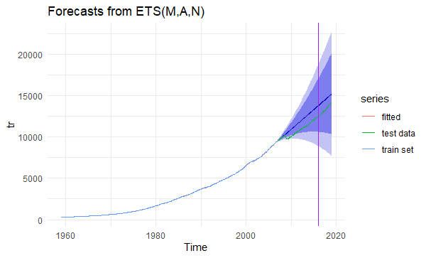

***Graph 10****: Forecast Plot of ETS*

We can say that almost good model.

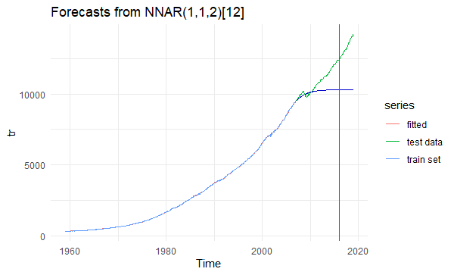

***Graph 11****: Forecast Plot of NNETAR*

The forecast plot shows that the prediction intervals appear to be not much too wide, it’s a bit narrow, this may indicate that the forecasts are accurate.

# DISCUSSION AND CONCLUSION

In this project, firstly, I divided the data into 2 as train and test. (80% of the data was used as train). Then, Box-Cox transformation was done, and data was cleared from unusual data. The stationary requirement did not satisfied (was understanded from Hegy test), our process has the stochastic trend. To solve this problem, differencing methods were applied. After making the process stationary, some models were suggested by using specific methods. Then, diagnostic checks are implemented on residuals. Normality, heteroscedasticity, and serial autocorrelation assumptions did not satisfy. Thus, ARCH and GARCH model can be used.

Four different forecasting method and ARIMA method were considered and the forecast from them are produced. At the end of this, ETS has the best performance.

In summary, in the process of analysis, despite of some problems, the best model could be obtained. Moreover, I have learnt that how to analysis time series data sets, how to interpret plots, results of some tests and how to find the forecast values of the series. In addition, I learned how to organize and clean data using R.

# REFERENCES

|  |  |  |  |  |  |  |
| --- | --- | --- | --- | --- | --- | --- |
| |  | | --- | | *FRED Economic Data*. (2022, January 28). [Dataset]. <https://fred.stlouisfed.org/series/PCE>  House Selling Price,» *Expert Systems with Application, Statistics Glossary - time series data*. (n.d.). Statistics Glossary.http://www.stats.gla.ac.uk/steps/glossary/time_series.html#timeseries7, Is  sue 3, pp. 1808-1813, 2010. | | A. Can, «In this projectThe Measurement of Neighborhood Dynamics in Urban House Prices,» *Economic Geography,* Vol. 66, Issue 3, pp. 254-272, 1990. | | H. Kim, S. W. Park, S. Lee ve X. Xue, «Determinants of House Prices in Seoul: A quantile Regression Approach,» *Pacific Rim Property Research Journal,* Vol. 21, Issue 2, pp. 91-113, 2015. | | H. Selim, «Determinants of House Prices in Turkey: Hedonic Regression Versus Artificial Neural Network,» *Expert Systems with Applications,* Vol. 36, Issue 2, pp. 2843-2852, 2009. | | S. C. Bourassa, M. Hoesli ve J. Sun, «A Simple Alternative House Price Index Method,» *Journal of Housing Economics,* Vol. 15, Issue 1, pp. 80-97, 2006. | | S. Lu, Z. Li, Z. Qin, X. Yang ve R. Goh, «A Hybrid RegressionTechnique for House Prices Prediction,» %1 içinde *IEEE International International Conference on Industrial Engineering and Engineering Management (IEEM)*, Singapore, 2017. | |
| H. Selim, «Determinants of House Prices in Turkey: Hedonic Regression Versus Artificial Neural Network,» *Expert Systems with Applications,* Vol. 36, Issue 2, pp. 2843-2852, 2009. |
| S. C. Bourassa, M. Hoesli ve J. Sun, «A Simple Alternative House Price Index Method,» *Journal of Housing Economics,* Vol. 15, Issue 1, pp. 80-97, 2006. |
| S. Lu, Z. Li, Z. Qin, X. Yang ve R. Goh, «A Hybrid RegressionTechnique for House Prices Prediction,» %1 içinde *IEEE International International Conference on Industrial Engineering and Engineering Management (IEEM)*, Singapore, 2017. |